22.40: a)(i) 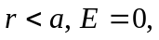 since the charge enclosed is zero.
(ii) 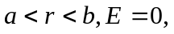 since the charge enclosed is zero.
(iii) 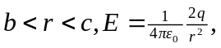 since charge enclosed is 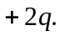
(iv) 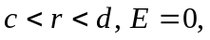 since the net charge enclosed is zero.
(v) 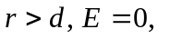since the net charge enclosed is zero.

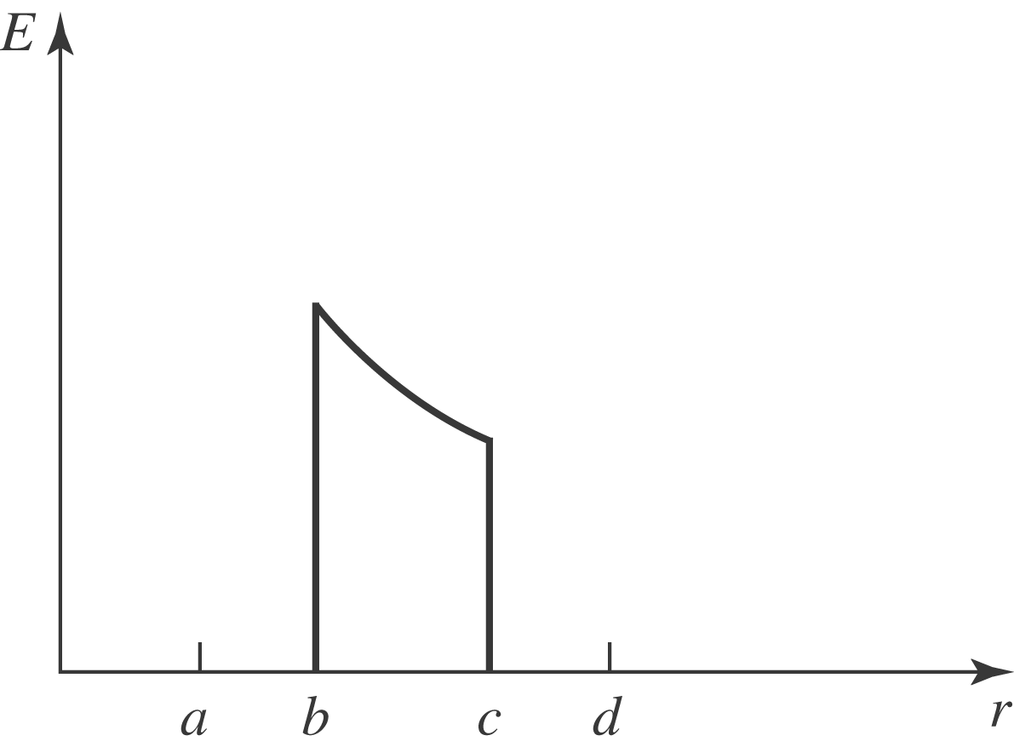

b)(i) small shell inner: 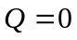
(ii) small shell outer: 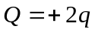
(iii) large shell inner: 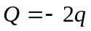
(iv) large shell outer:

